Website project proposal
Skinner Café Website Development Proposal

Subject: Web Development
Subject Code: WEDE5020
Prepared by:
Full Name: Rhulani Nkuna
Student Number: ST10501757
Target Organisation: Skinner Café
Organisation Type: Small Business (Coffee Shop & Café)
Lecturer: Mr Rhulani Kobeni
Institution: Rosebank College

Organization
Name: Skinner Café

Type of Organization
Small Business (Coffee Shop & Café) Location
70 Juta Street, corner of Juta and De Beer Street, Braamfontein, Johannesburg, South Africa.

Organisation Overview
Skinner Café Braamfontein is a small Café shop owned the property group play Braamfontein. Skinner Café opened its doors to the public in mid-2025 and quickly established itself as a centrepiece for local community runners, creative meetups and media productions on Juta Street. The shop is a vibrant urban coffee shop and coworking space that act as a cultural anchor blending premium Coffee with the inner-city creative scene.

Mission
Skinner Café wants to act as a Neighbourhood Creative Hub by providing a reliable high ambience workspace for local students, digital creators and artists in the inner city. Serve as an inviting "urban anchor" on Juta Street that sparks organic creative collaboration and friendly conversation and keep inner-city food and coffee culture vibrant with a rotating menu of artisanal bakes and treats

Target Audience
- University students
- Young professionals
- Coffee lovers
- Freelancers
- Tourists
- Creative community

Website Goals
- Promote the café and its brand.
- Display the menu and featured drinks.
- Allow customers to enquire about rooftop bookings.
- Showcase events and promotions.
- Provide location, opening hours and contact information.
- Increase customer engagement

Current Website Analysis
Skinner Café currently has no dedicated website but it has a dedicated online home via the official Skinner Cafe – Play Braamfontein Page for venue bookings. Its only online presence is an Instagram page and a Facebook business page.
Weaknesses identified:
- Poor discoverability – customers searching "coffee shop near me" or "cafés in Braamfontein" on Google won't find the business, since search engines prioritize websites over social media pages
- Missed local SEO opportunities – no way to rank for local searches, meaning competitors with websites capture that traffic instead
- No online ordering or reservations – lost revenue from customers who'd order ahead or book a table if given the option
- No email list for events or promotions — There's no reliable way to reach past customers about specials or events. A website-driven email list would offer a direct marketing channel, independent of social media algorithms.
These weaknesses indicate a clear need for a responsive easily maintained website with a strong local SEO.

Proposed website features and functionality
The proposed website will include the following core pages and functionality
- Home page – hero banner, brief introduction and call to action buttons.
- About Us - café history, mission and vision.
- Menu – categorised beverage and food listings with prices.
- Gallery – photographs of the café interior, food and events.
- Contact – embedded Google Map, opening hours and a contact/reservation form.
- Footer

Design and User Experience
Colour Scheme: Warm natural colours that reflect the café’s cosy ambiance


Typography: Inter (bold) for headings to convey a modern feel

Sitemap
Home.html
• Menu.html
• gallery.html
• About.html
• contacts.html
Layout and design: A clean minimalist layout designed mobile first to ensure fast load times
A low-fidelity wireframe of the proposed homepage layout is shown below, illustrating the intended information hierarchy:

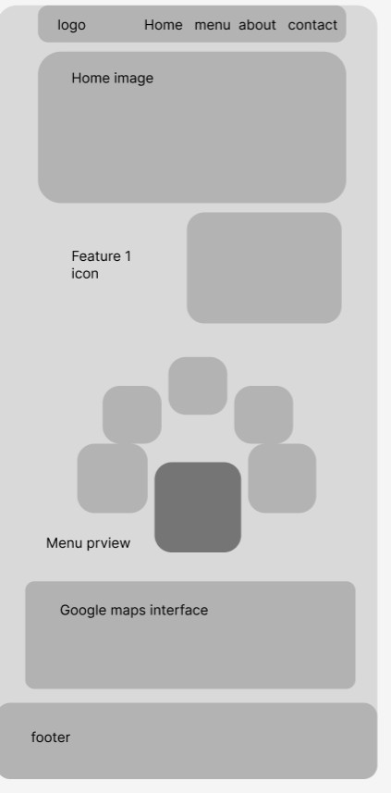

Technical requirements
The website will require the following technical resources:
- Domain name: Skinnercafé.co.za
- Front end languages: HTML5, CSS and JavaScript for structure, styling and interactivity.
- Content Management System: to allow the café staff to update the menu and content without coding knowledge.

Timeline and Milestones
Week 1: Research and planning.
Week 2,3 and 4: Development.
Week 5: Testing and refinement.
Week 6: Launch and review

Budget
Domain registration (.co.za): R105 one-time/ annually
Web hosting: R1308 Annually / R109 monthly
Website design and development: R1600

References
Afrihost – web hosting packages.
Xneelo – Domain registration and hosting.
Skinner café.
Play Braamfontein.

